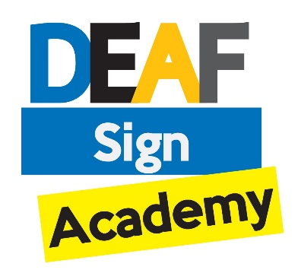
BSL Courses - Interest

Name:

Address:

Contact Number:

D.O.B :

Email Address:

Deaf/Hearing/hard of Hearing etc.: (Please mark one)

We are looking to start all courses in September, Dates and time to follow

Please select the course that you are interested in

BSL Level 1

BSL Level 2

BSL Level 3

Please select your preferred day to learn

MON TUE WED THU FRI SAT SUN

Any further questions please contact us on 0161 945 6058 or email: daniel@interpretingsolutions.co.uk

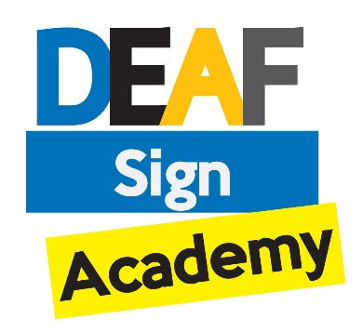

Where did you hear about our sign language course?

Signature Website
IS Website
Facebook
Twitter
Work Place

If yes where do you work? --------------------------------------------
Friend / Family
Our Poster
(Library, Hospital, College, Mosque ect...)
If yes where was the poster? --------------------------------------------
If none of above, Where? --------------------------------------------

